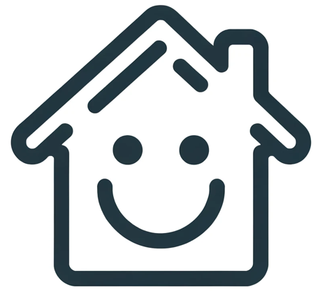
- Please respect check-in and check-out times.
- No unregistered guest allowed.
- Please respect the noise curfew.
- No illegal substances allowed on the premises.
- No smoking allowed.
- No parties or events allowed.
- Please don't eat or drink in the bedrooms.
- Please clean up after yourself.
- Please turn off the AC and lights when you go out.
- Please take care of the furnishings.
- Damages exceeding the security deposit will be charged.
- Please take the trash out before you leave.
- Please don't rearrange the furniture.
HOUSE RULES

