Please
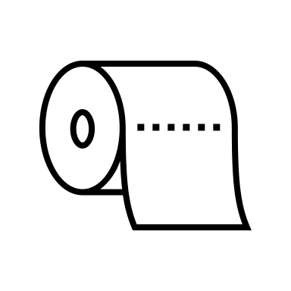
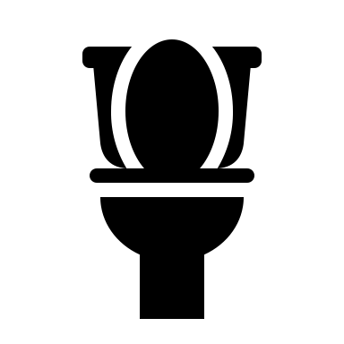

DO NOT FLUSH ANYTHING OTHER THEN TOILET PAPER

THANK YOU FOR YOUR COOPERATION!

