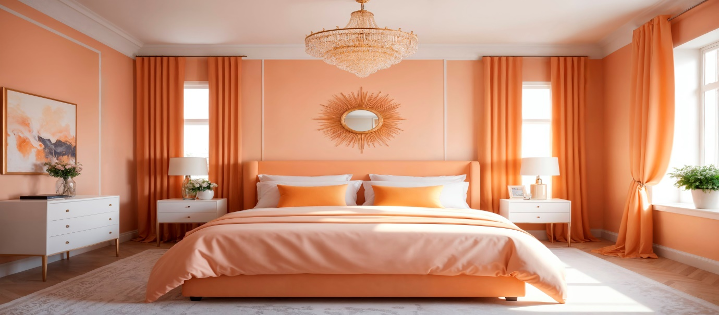

Check-In Time: 3:00 PM
Welcome to our homestay! Check-in is at 3:00 PM, allowing us to prepare the room thoroughly for your arrival. If you anticipate arriving outside these hours, please inform us in advance so we can make suitable arrangements to welcome you. We aim to ensure a smooth and pleasant check-in experience for all our guests.

Departure: Check-Out Time: 11:00 AM
We hope you enjoyed your stay! Please plan to check out by 11:00 AM to allow us time to prepare the space for our next guests. Before leaving, ensure you have all your belongings, return the keys, and leave the room in good condition.

Safe travels, and we hope to welcome you back soon!

