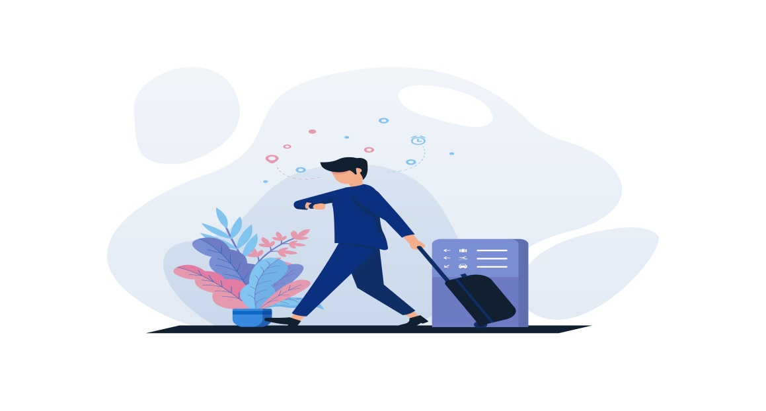
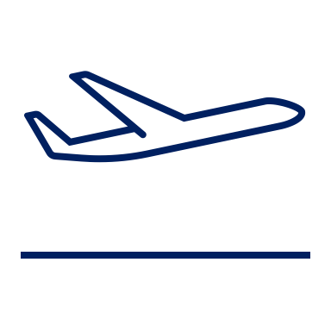
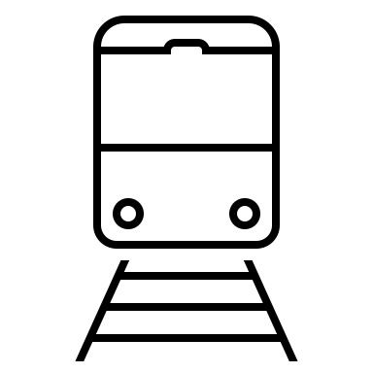
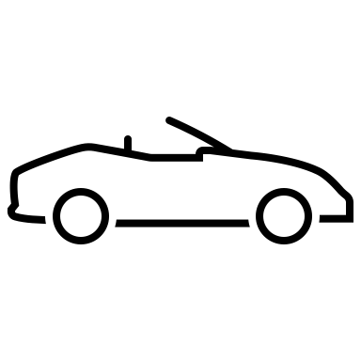
Before You Leave

Please ensure the following before you leave:

- Gather all your belongings.
- Close and lock all windows.
- Lock all doors.
- Turn off the AC and TV.
- Return any keys to the safe deposit box.
- Set the thermostat to 67°F.

Thank you for your cooperation! Safe travels!

