HOUSE RULES

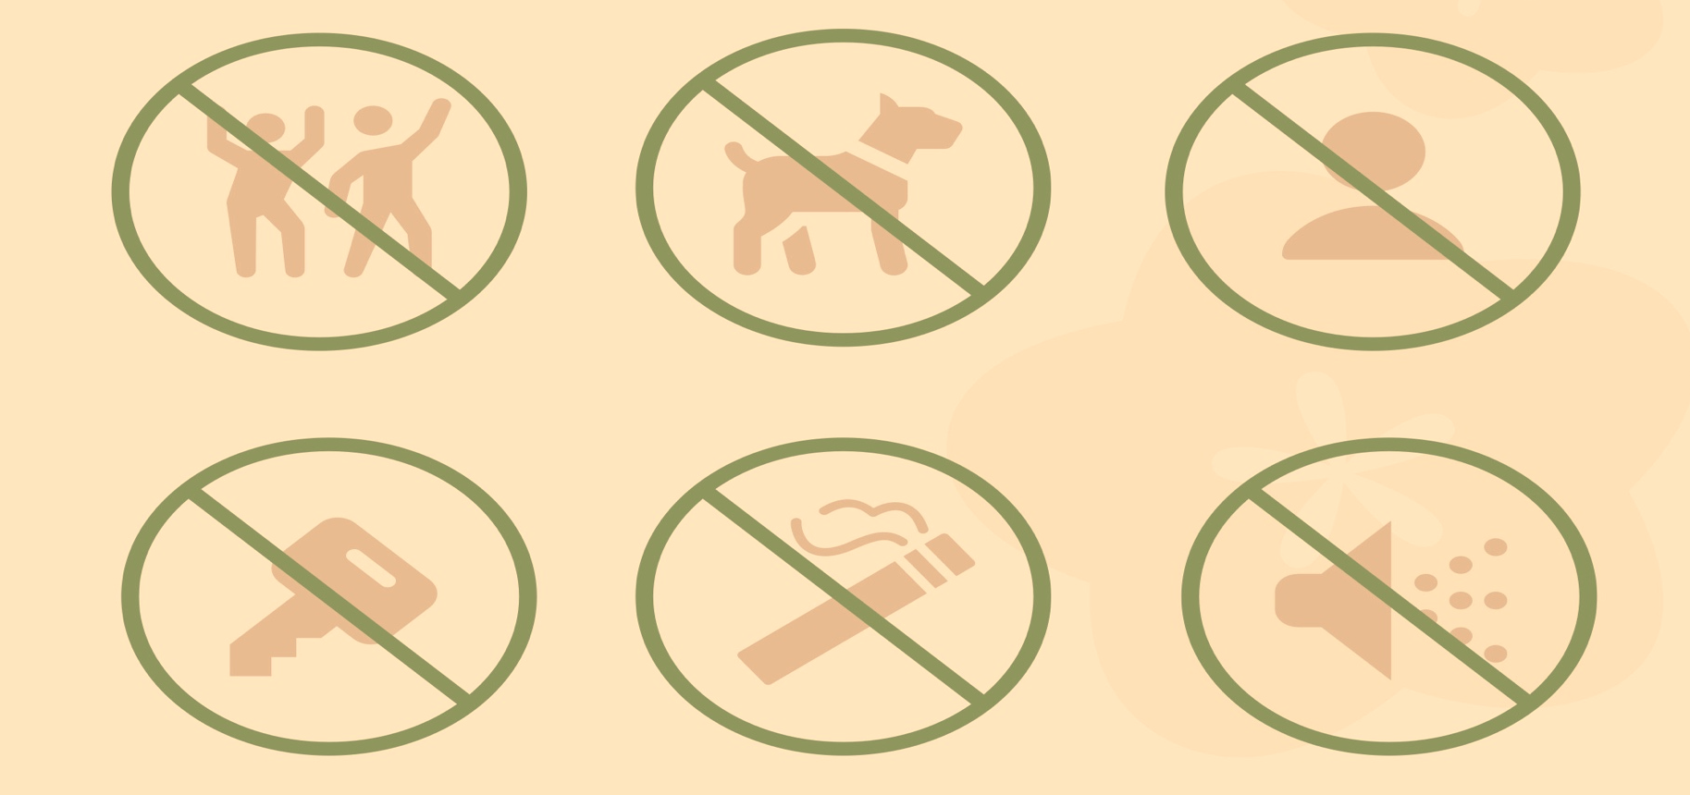

- No Parties
- No Pets
- No Unregistered Guest
- Minimize Noise
- Lost Key Fee
- No Smoking

