WELCOME TO HOMEYHUTS

GET CONNECTED:
WIFI NAME: DIR -615
PASSWORD: 79113915

HOUSE RULES:


- Respect quiet hours from 11pm to 6 am
- Unannounced guests will not be allowed
- Keep the space clean
- Smoking indoors is prohibited, smoke detectors are installed for your safety.

THINGS TO KNOW:

- Housekeeing can be available on request from morning to evening
- Early check-in and late check-out will be subject to availability. Charges may applicable for the same
- Any narcotics / drugs are not permitted

CHECKOUT INSTRUCTIONS:
- Check out is at 11 am

- Make sure to close all windows and doors
- Turn off the utilities
- If you liked staying with us, leave us a 5-star review!

DAMAGE POLICY:
- Our team will inspect the property after your departure to assess any damage. This includes both visible and reported damages.
- If any damage is noticed upon your arrival, please notify us within 1-2hours. To avoid being held responsible for preexisting issues.
- Any damage incurred during your stay will result in a deduction from your security deposit or extra charges to cover the damage.

GETTING AROUND:
- To reach our property, please follow the google maps link provided. Once you reach near bhimtal lake, take a turn around mandir marg. If you encounter any difficulty finding the location, please don't hesitate to contact our caretaker for assistance.
- If needed, you can also reach sojourn by the lake, boutique hotel first and re-enter the directions in google maps from there. We look forward to welcoming you to our property!
- Additionally, we recommend informing the caretaker 30 minutes before your arrival for a smooth check-in process
- PLEASE NOTE: there is some slope and little hilly drive so if you’re a seasoned driver that shouldn’t be an issue, all kind of cars can easily drive up to the property.
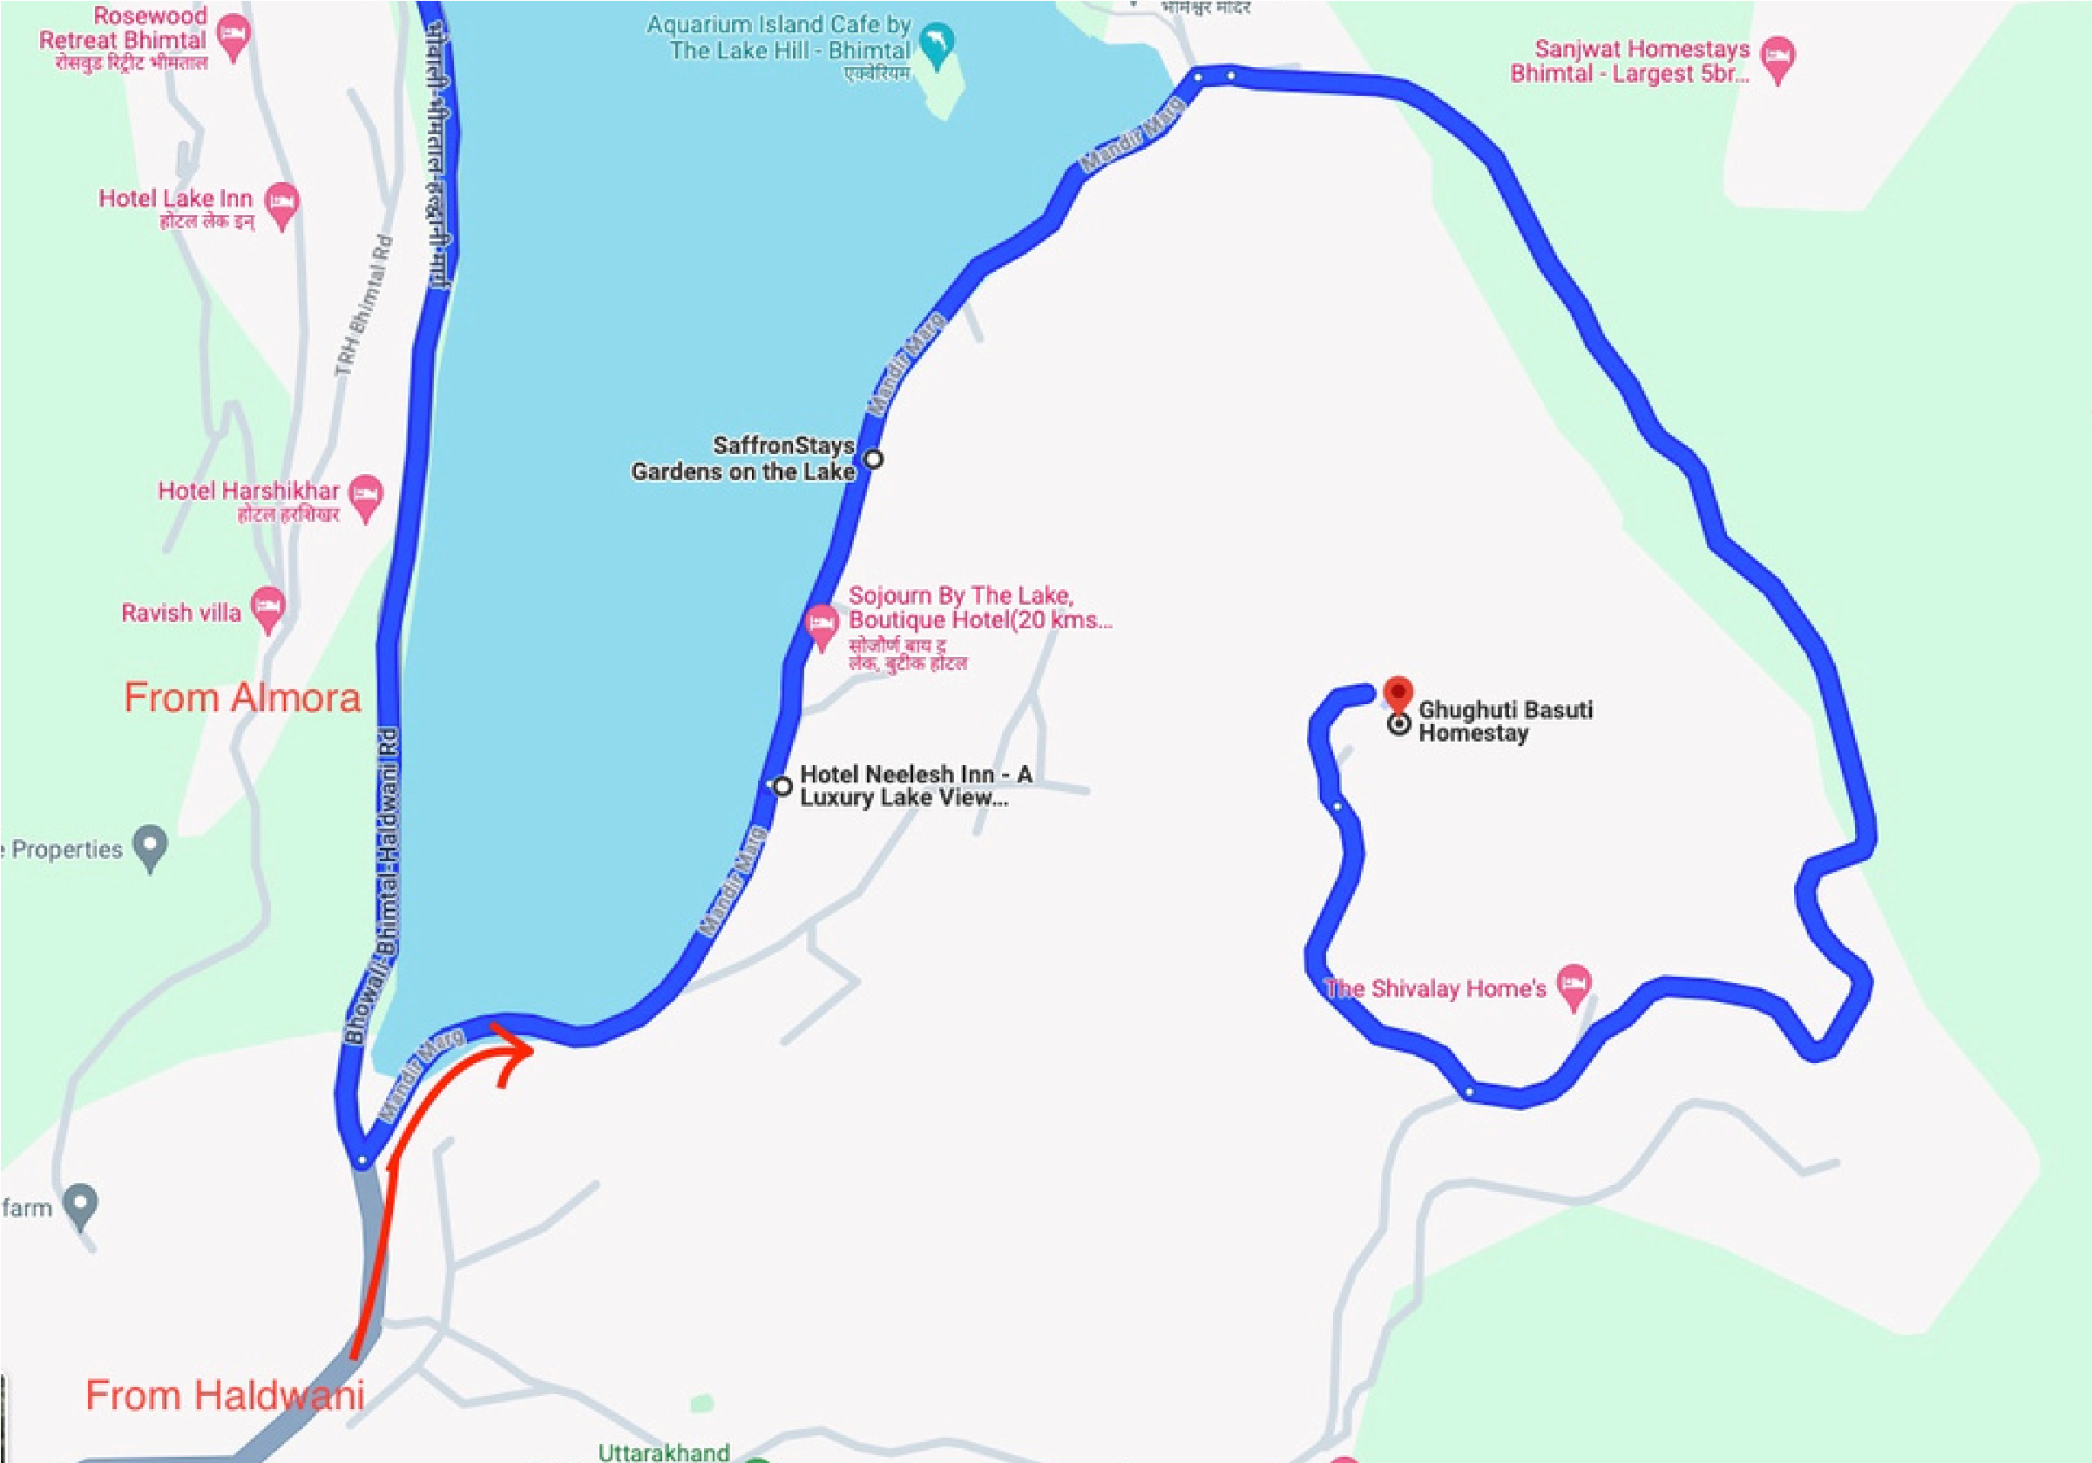

PLACES TO VISIT NEARBY

- Nainital
- Mukhteshwar
- Kainchi dham
- Sattal
- Naukuchiatal
- Aqaurium Island Café
- Do Baati Restaurant
- Activities nearby: lakes, boating, paragliding, water sports, temples

