Before You Leave, Please.
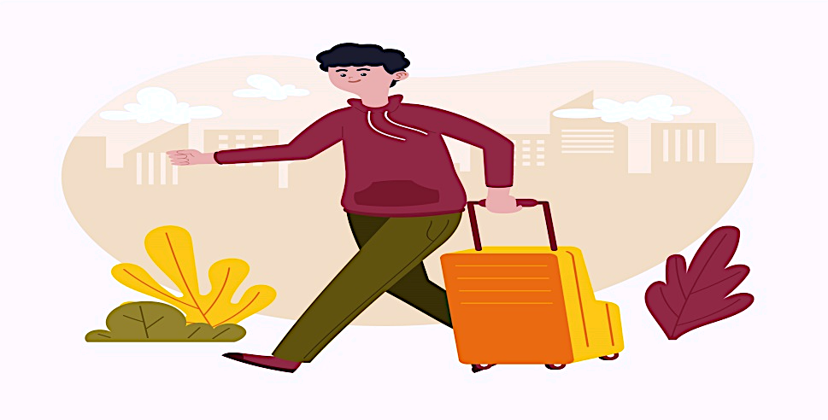

- Tidy your room and any common areas you used.
- Ensure you have all your belongings.
- Leave the keys where instructed or hand them to the host.
- Send a quick message to the host confirming your departure and thanking them for your stay.
- If possible, take a few minutes to leave us a review. Your feedback is important to us.
THANK YOU!

