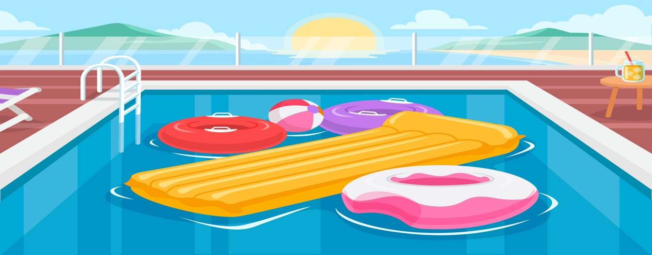
POOL RULES

Welcome to Our Pool.
- Shower Before Swimming: Please shower to help keep the pool clean.
- No Running: For your safety, avoid running around the pool area.
- Supervise Children: Children must be accompanied by an adult at all times.
- No Diving: Diving is not allowed; please enter the pool feet first.
- No Glass Containers: Use plastic or non-breakable items around the pool.
- Keep it Clean: Dispose of trash properly and take personal items with you.
- Food and drinks should be kept out of the pool, and all trash should be disposed of in the provided bins.
- Respect Quiet Hours: No swimming during quiet hours from [insert quiet hours] to respect other guests.
- Use Towels: Please dry off before entering the house.
- Emergency Contact: insert emergency contact number.
Thank You for your co-operation!

